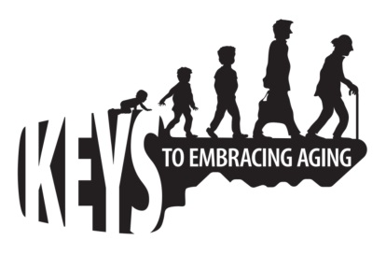

SAMPLE SUCCESS STORY

_____(Name of County, State)_______ presented Keys to Embracing Aging to (total #) participants. As a result of the program, (# or % to Q3 who indicated “strongly agree” or “agree”) participants reported a better understanding of how current lifestyle behaviors affect future health and well-being. Specifically, (# or %) participants reported aspirations to better embrace a positive attitude. (# or %) participants reported the need to be healthier eaters (# or %) and (# or %) declared the need stay on top of their health numbers. (# or %) participants plan to increase physical activity, (# or %) mental activity, and (# or %) social activity. (# or %) participants recognize the need to practice safety and (# or %) intend to tune-in to the times. (# or %) participants anticipate practicing stress management, (# or %) getting financial affairs in order, (# or %) getting more quality sleep, and (# or %) taking at least 10 minutes for themselves each day.

(# or % Q4 who indicated “strongly agree” or “agree”) participants better understand how lifestyle behaviors and choices are integrated, and (# or % Q5 who indicated “strongly agree” or “agree”) participants indicated an increased understanding of how healthy choices promote a longer, healthier life. For example, financial problems can affect health status and vice versa. Financial distress may result in the inability to eat well, seek routine check-ups or plan for retirement. Delayed or inadequate treatment creates a greater risk for stress, illness, problems with sleeping and ultimately higher health costs.

Keys to Embracing Aging reinforces the strong association between healthy lifestyles and prevention and additional years of life. The financial impact of improved health behavior includes immediate and long-term savings. By cutting out the cost of unhealthy habits such as a $10/day smoking or junk food habit, over $3,650 can be saved annually. Further, estimates suggest that an obese person will spend 36% more than average-sized people on health services and 77% more on medications. Delaying the onset of a disease such as diabetes can save even more thousands of dollars annually in increased medical costs. Inactivity has even been estimated to cost between $670 and $1,125 per person per year. (Continued on back)

In general, higher health costs affect those with health challenges (e.g., hypertension and diabetes) the most, due to the ongoing cost of prescription drugs, deductibles, co-payments, and other expenses. Rising health care costs have been shown to directly affect household finances, including choices to decrease contributions to savings accounts, including retirement savings plans. Healthy lifestyle choices, such as proper diet and exercise, increase the odds of living a long and healthy life. People who live longer, healthier lives have more time to grow their savings for themselves, as well as for their survivors and heirs.

Note: When writing success stories, always write out the number of participants. Do not use the numeral. When referring to percentages, always use the numeral and write out the word percent, as in: 14 percent.
Source: Rutgers (2012). The financial impact of improved health behaviors. http://njaes.rutgers.edu/healthfinance/health-behaviors.asp

